**Portfolio 1 – Software Development**

**Victor Nielsen – 74762**

**Introduction:**

For the first portfolio of the semester, I will work in two different situations related to object-oriented programming and software engineering. Both of them will focus on how to implement classical OOP models and understand and apply software requirements.

The portfolio will be split in two main parts, in which each of them will target different situations:

* The first part will be based in create all the necessary environment and plan all the necessary tasks to create a small shapes model, which will contain basic forms as rectangles, triangles and circles; but also being designed with extensibility so other shapes could be added in the future without changing the basic model. For that, the first part will focus on:
* Establishing a development environment (in this case, using Git, Github, JAVA and InteliJ)
* Designing the application (using UML from building use case diagrams to static and dynamic models of the app)
* Planning the development of the application (using Trello – which is Kanban based)
* The second part will be the implementation of the model itself. It will have a common behavior, so that each shape instantiated can return:
* Its center
* Its area
* Its circumference
* Indicate whether or not a point is inside of it
* Compute the Euclidean distance from its center to the center of another shape
* Future additional behavior (… -> Add here)

The design of the shapes will be made in UML and implemented in JAVA.

Resuming, the second part will be made of:

* An overall description of the shape model
* UML diagrams documenting representation and behavior of the shape model
* An implementation of the shape system
* Unity tests verifying behavior for all shapes

**First part (Shapes model):**

**Development environment:**

To implement a shapes model, based on the specifications given by the portfolio, I first started my development environment.

For that, I started creating a project in InteliJ using Oracle OpenJDK version 11.0.11.

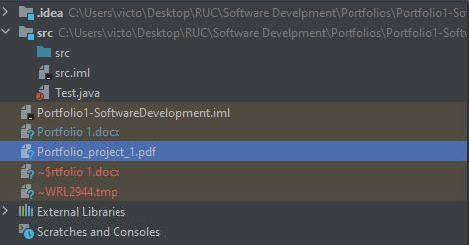

After that, I started Git in the project and imported it to a Github repository.

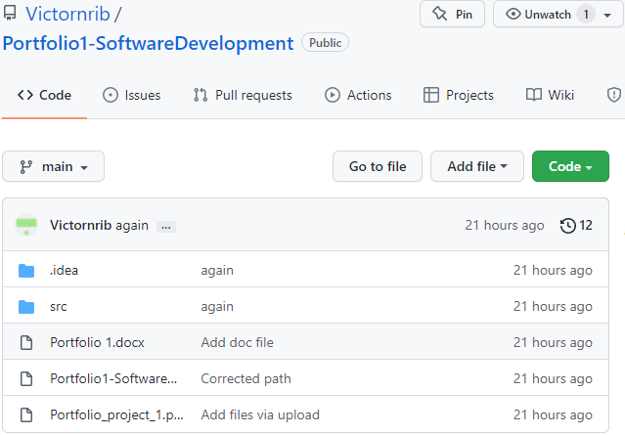

I did a remote repository because even being in a project alone, it still gives me the ability to update my application from any device, and not only my local one. Apart from that, it also allows me to add more developers to the project in the future.

**Design of the application:**

For the app design, I started doing a class model

Dynamic UML diagram

